Leaking route from vpn-instance to global routing table.

**Labels: HPE Comware Switch**

**Requirement:**

Leak route from BGP routing table to global routing table

**Solution:**

Solution is to use route-replicate command inside public-instance view.

**Configuration:**

Below we can see that BGP route is advertised within a vpn-instance.

[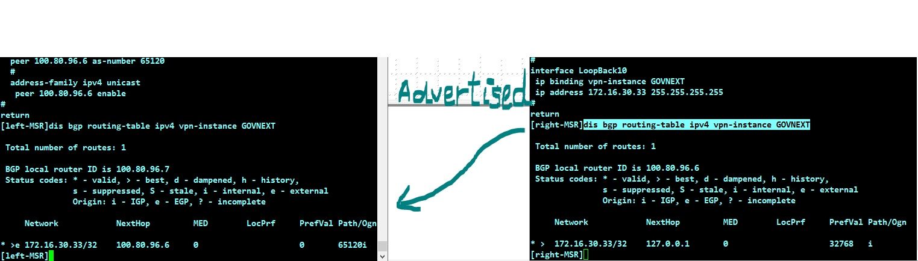](https://akb.arubanetworks.com/media/ckuploads/1110/2022/06/30/inkedbgp-advertisement-bgp-vpn-instance_li.jpg)

 By using route-replicate command inside public-instance we could get the same route in global routing-table.

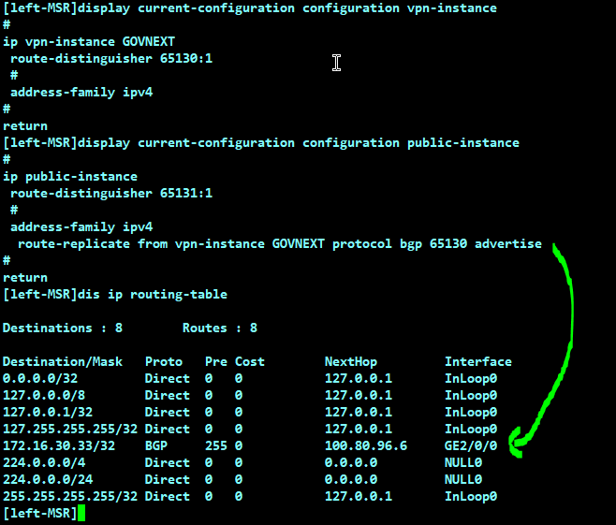

**Verification:**

Please note that route-replicate command is not available in older version.

It is available from  Release 0821P11 onwards.  
Also available in **MSR4000_7.10.R0809P33 and MSR4000_7.10.R6728P15 which**were released after Release 0821P11

Tags: HPE Comware Switch, 10.01.0040, route leak, #msr, #comware